Response to the questions

Reviewer1:

Reviewer2:

Q:Throughout the paper the assumption has been made, apparently, that an event causes a signal on a strip, thus on one strip only. Since this assumption is not argued nor clarified, the bases of the 'reconstruction' vanishes.

A: You are right. The basis of the induced encoding readout method is that an event causes only one signal on anode strip. If two or more adjacent anode strip is hit at the same time because the event has a certain width, the decoding will be wrong. To ensure that only one anode strip is hit when an event comes, we use packet coding techniques. As shown in Fig. 1, the adjacent anode strips are assigned to different groups, which are encoded and decoded individually. In this way, an event with a certain width will not hit more than one strip of one group. The number of group is decided on the width of the event and the width of the strip. At the same time, the strips can be smaller. A higher position resolution can be obtained by the charge-center method.

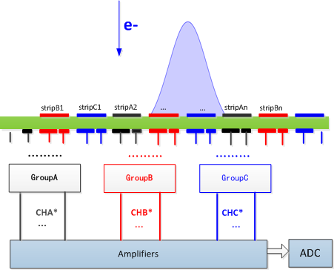

Fig. 1. Schematic of packet codeing techniques

Q: A strip signal is split in two parts with a certain ratio. This ratio has probably an optimum, since it does not work if the ratio is 1 or 0. This issue is not addressed at all.

A: In order to select the optimized width ratio of the two induced strips, we used ANSYS's software Designer and SIwave to simulate signal integrity. The relationship between the larger signal and the smaller signal at different ratios have been shown in Fig. 2. It's necessary to ensure that not only the signals on the two induced strip have enough difference, but also the smaller signal can be distinguished easily from noise. The Fig. 3 shows the output signal of each channel when the width ratio is 2. It can be seen from Fig. 3 that the smaller signal has enough recognition degree from noise. As a result, we took the width ratio of 2:1.

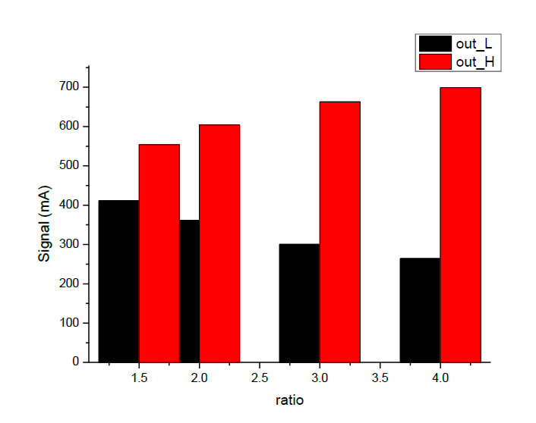

Fig. 2. the output signal of wide strip and narrow strip under different width ratio

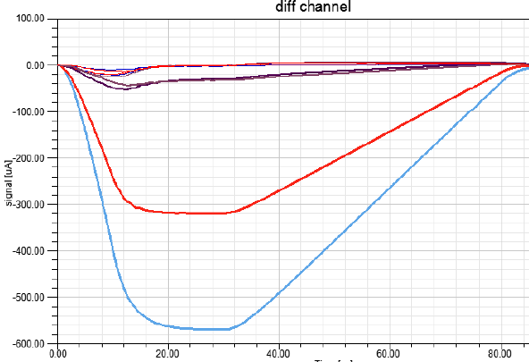

Fig. 3. output signal of all electronic channels when ratio is 2:1

Q: From the raw data of an event in fig 4, the signal distribution over the strips is claimed to be possible. This reconstructed event should have been shown. From that, the width of the distribution over the strips would at least have been indicated.

A: Fig. 4 shows the signals recorded on all 15 electronic channels when an event hit. There are 47 anode strips, which are divided into 3 groups to be encoded and decoded individually, and the width of each strip is 1.07mm. The baseline noise is about 2.5fC. We take 2σ of 5fC as the noise threshold to filter the valid signals. It can be inferred that the valid channels are channel 2, channel 4, channel 12 and channel 14. Channel 2 and channel 4 belong to group 1, from which the hit strip of strip 25 can be decoded. The Channel 12 and channel 14 means that strip 26 is hit, too. According to the distribution of charge on the two strips, the true hit point is strip 25.25, and the width of the event is about 2 strips, which means 2.14mm.

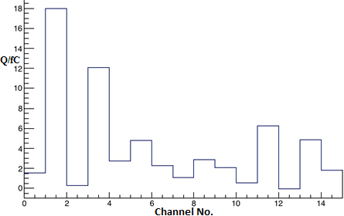

Fig. 4. The signal recorded on 15 channels when an event hit

Q: Fig. 5 shows spatial resolution, but is has no meaning since no info is available

about issues determining this spatial resolution. The same is true for figs 6 & 7.

A: Fig. 5 shows the decoded spatial resolution result of the detector. A large number of statistics have been made for a fixed X-ray incidence location. The root-mean-square (RMS) of the statistical histogram is 1.69 strips, which mean the resolution is 1.8mm, considering the width of anode strip is 1.07mm.

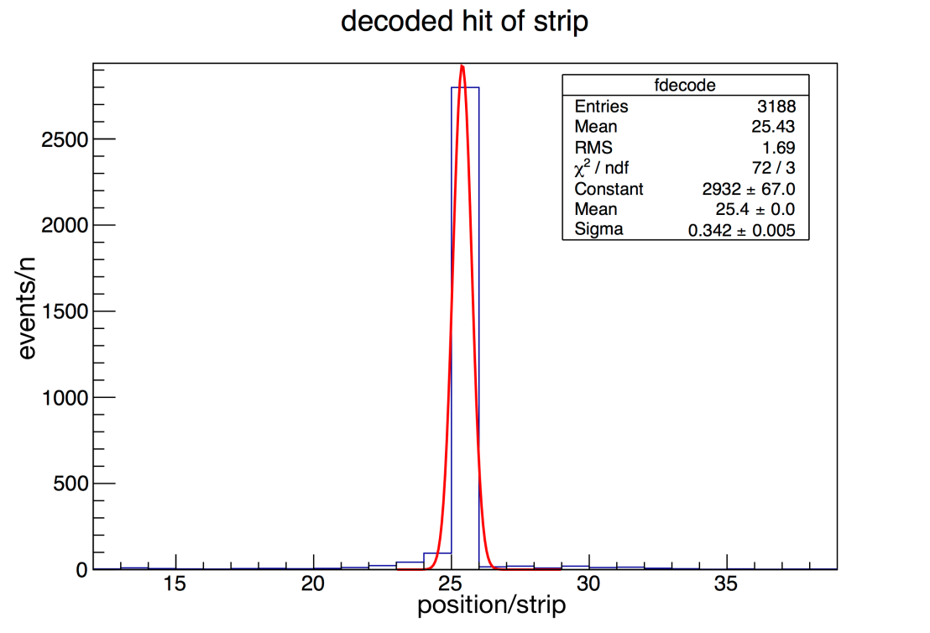

Fig. 5. Spatial resolution results of the detector

Fig. 6 shows the results of linearity in the position scanning test. The test setup has been shown before. During the test, the detector was moved with a step of 0.5mm every time. The X-axis of Fig. 6 means the time of the scanning, and Y-axis means the decoded anode strip of each time. P0 shows the slope of the fitted red line, which means the step of every movement is 0.464 strips (0.496mm). It's very close to the real step of 0.5mm.

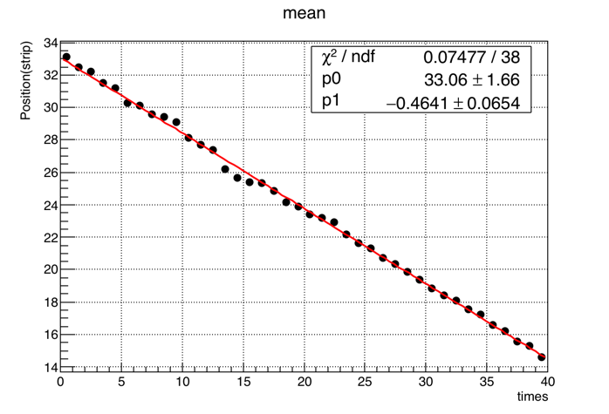

Fig. 6. Linear result of position scanning test

Fig. 7 has been cancelled since it is not easy to explain and does not have much help to this paper.

Reviewer: 3   
  
Comments and suggestions for the author   
Overall, careful proofreading is necessary. I find several mistakes in English.   
  
Q:Page1, In the footnote, you should show the authors’ affiliations.   
A: The authors’ affiliations have been added in the footnote:

“Shubin Liu is with State Key Laboratory of Particle Detection and Electronics, University of Science and Technology of China, No.96, Jinzhai Road, Hefei, Anhui, China (e-mail: liushb@ustc.edu.cn).”

Q:Page 1, right, line around 22,   
“Thick GEM, and verification …”   
should write like this “Thick Gas Electron Multiplier (THGEM), and verification …”   
A: This place has been rewrite.

“Thick Gas Electron Multiplier (THGEM), and verification”

Q:Page2, left, line around 6   
“could be uniquely decoded as seen in Table I”   
should be “Could be uniquely decoded as seen in Table I.”   
A: This has been rewrite.

“Could be uniquely decoded as seen in Table I”

Q:Page2, left, line around 59,   
“According to the Table 2,”   
should be  “According to the Table II”   
A: This place has been rewrite.

“According to the Table II”

Q:Page2, right, line around 39,   
“As shown in Fig.3., verification tests …”   
should be “As shown in Fig. 3, verification tests …”   
A:This place has been rewrite.

“As shown in Fig. 3, verification tests …”

Q:Page2, right, line around 40,   
“THGEN detector using a 8keV Cu X-ray and Ar/iC4H10 (97:3) gas mixture.”   
This sentence is very confusable. You should separately explain the gas used in THEGEM detector, and the X-ray source.   
A: This place has been rewrite.

“As shown in Fig. 3, verification tests were carried out on the THGEM detector, which is filled with Ar/iC4H10(93:7) gas mixture. A 100 μm [slit](javascript:void(0);) in a thin brass sheet was used to produce a miniaturized X-ray beam.”

Q:Page2, right, line around 55,   
“platform was used for the postion scanning test.”   
should be “ platform was used for the position scanning test.” “

A: This place has been rewrite.

“platform was used for the position scanning test.”

Q:Page2, Fig.3.   
In the picture, you show “X-ray”, but it should be written as “X-ray source” .   
A: This figure has been modified.

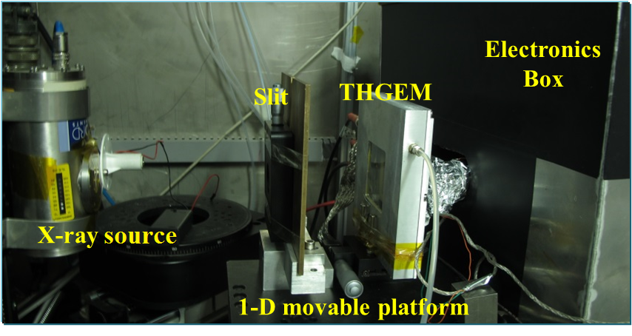

Fig. 7. Experimental setup

Q:Page 3. from left line 59 to right line around 3,   
“channel 2 and 4” … “the detector is 0.4 strip (0.43mm).”   
around here, I find English mistakes. Please correct.   
A: This place has been rewrite.

“The channel 2 and 4 are valid, and it can correctly decode the hit position by the encoding form.”

Q:Page 3, right around 6,   
“position scanning test”, what is the position scanning test? It is the same as verification test as explained before?   
A: Explanation

“Fig. 8 shows the results of linearity in the position scanning test. The test setup has been shown before. During the test, the detector was moved with a step of 0.5mm every time. The X-axis of Fig.8 means the time of the scanning, and Y-axis means the decoded anode strip of each time. P0 shows the slope of the fitted red line, which means the step of every movement is 0.464 strips (0.496mm). It's very close to the real step of 0.5mm. “



Fig. 8. Linear result of position scanning test

Q: In Fig 4. what is the unit of Y axis. Please show on the figure or explain in the text.   
A: The unit of Y-axis is fC and the unit of X-axis is the number of electronic channel.



Fig. 9. The signal recorded on 15 channels when an event hit

Q: Fig 5. It seems, you simple fit the Gaussian function. However, this spectrum is not a Gaussian distribution.  In general, you should use RMS (root-mean-square) to discuss resolutions.

A: I have added the RMS in the figure to discuss the resolutions. The figure is shown at the next answer.

Q:What is the meaning of “events/n” in the Y-axis, and “position/strip” in the X-axis? Please explain.   
A: The X-axis of Fig. 10 means the number of decoded strip. The unit event/n of Y-axis means the statistical counts on each anode strip. The histogram of Fig. 10 is to show the position resolution if I illuminate the same location of the detector with X-rays. The RMS (root-mean-square) of position resolution is 1.69 strips, which means 1.80mm.

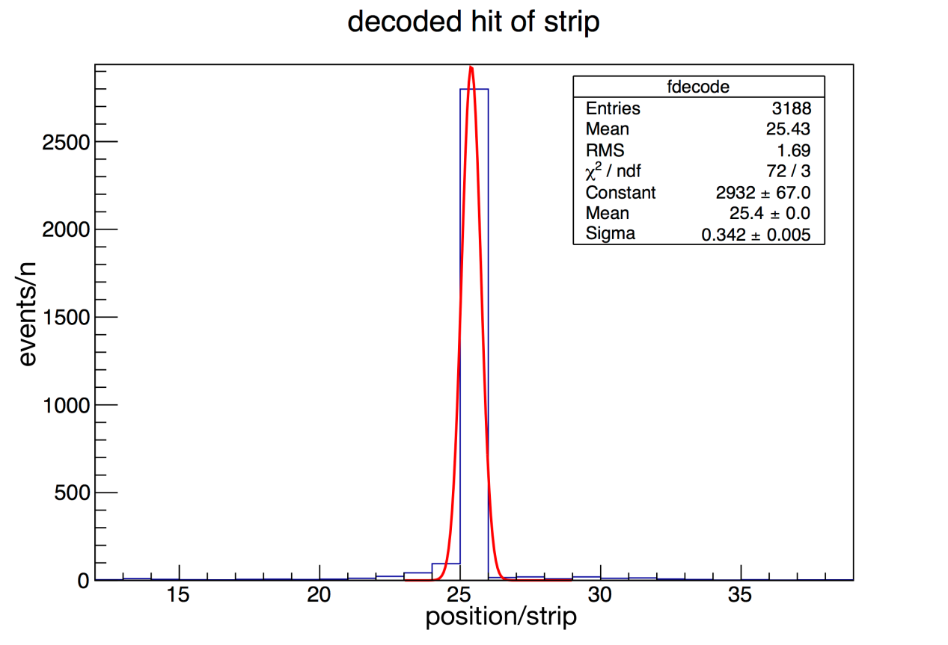

Fig. 10. Spatial resolution result of the detector

Q: Fig 6.   
what is the meaning of “times” in the X-axis? What is the unit of Y-axis, mm? or the strip number?  What is the red line? What is the values of p0,p1 in the figure?   
A: In Fig. 8, the “times” in the X-axis means the number of scanning time. We move the detector 0.5mm every time. The Y-axis means the decoded strip number. The width of the strip is 1.07mm. P0 shows the slope of the fitted red line, which means the step of every movement is 0.464 strips (0.496mm). It's very close to the real step of 0.5mm.

Q: what is the blue line?   
Fig 7, what are the X and Y axes?   
A: I cancelled the Fig. 7 because this figure was not easy to explain and didn’t have much effect on the integrity of the article.

Before Conclusion,   
I couldn’t any discussion. For example, “The test results indicate that the method can correctly decode the hit position, and have a good spatial resolution and linearity in its position response.” is written in the conclusion. You have to quantitatively describe “how good the spatial resolution is?” using some numerical numbers or some other ways.   
A: The quantitative resolution has been added to the conclusion. The decoding accuracy rate which is used to describe the performance of this encoding method has been added to the article.

“The test results indicate that the method can decode the hit position. If the threshold is set to twice the noise, the correct rate of decoding can reach 94%. Concerning the correct rate of decoding, the RMS of the position resolution is 1.69 strips, which means 1.808mm.”

In the references, you should include the paper of Bin-Xiang Qi et al., Chinese Physics C 40, 056102 (2016). This work is quite similar to yours. Please explain the difference between previous paper and your paper to us (editors and reviewers).

A: The two papers have some similarities in coding ideas and verification tests, so I will include that paper. But the research direction of this method is very different from that in the paper Bin-Xiang Qi et al., Chinese Physics C 40, 056102 (2016). I will elaborate on these differences. The most important difference is that these two methods have different bases of assumptions. Mine is based on the assumption that the event hit only one anode strip. If the event hit more than one strip, the decoding will be wrong. While at the same time, the other method is based on the assumption that one event hit more than one strip. Only in this case can the event be decoded correctly.  Another difference is that the anode plates have different structures. As is shown in Fig. 11, the other method's anode strip is connected to amplifiers directly, but in my method, the induced strips instead of anode strip are connected to amplifier, which means the induced charge is sent to amplifier, not the charge from detectors. What's more, the encoding and decoding of the two methods are different. In my method, n electronic channels can handle up to A2 n strips, but his method handles up to C2 n strips.

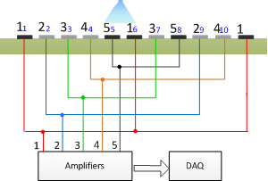

Fig. 11. Schematic of structure of direct encoding method

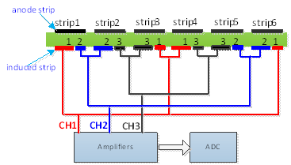

Fig. 12. Schematic of structure of induced encoding method